Chapter 2 - The Environment
Prior to coming to grips with Windows security, COM servers and services often seemed somewhat mystical to me – exactly what was it that allowed them to run in the background (even while no human was logged on to the machine)? Once I discovered how security dictates the environment in which a process runs (via logon session: window stations, and profiles), I quickly developed an intuition for the way Windows works that I would never have had otherwise. I now find systems programming on Windows much more comfortable because I can make predictions about how my programs will behave that never would have even considered before.
If you are developing distributed applications (or even just services that run in the background on the local machine), you should make it a prior to know what "run in the background" really means. You should be aw; that writing daemons is very different from writing interactive applications. This chapter, along with Chapters 4 and 5, aims to help you develop this intuition.

Logon Sessions
During my day-to-day life at DevelopMentor, I am occasionally called upon to teach a class on location at a client's site. At most organizations, each day when I arrive in the morning I am invariably required to prove my identity to the security guard at the front desk. The guard gives me a badge that I must wear during my stay and return before I leave. The security guard has authenticated me and given me the badge so that I won't have to suffer the authentication process (it's more rigorous at some organizations than at others) at the entrance to each room I need to traverse. The badge is simply a mechanism that promotes efficiency and helps prevent others from making mistakes, and therefore is a great analogy for a logon session, which basically does the same thing for principals in the Windows operating system. With a badge, anyone in the organization can quickly verify my identity and authorization level. With a logon session, any subsystem on the machine can quickly verify a principal's identity and authorization attributes.
When Alice logs in to AlicesMachine in the morning, AlicesMachine challenges Alice to prove her identity by requesting a password. The operating system takes this information and hands it off to the LSA for AlicesMachine (the LSA is analogous to the security guard), which verifies the password (this may require communicating with Alice's authority over the network) and creates a logon session for Alice. The logon session is one of the cornerstones of the environment within which Alice works, and developers of distributed systems should have a clear understanding of its role.
A logon session has classically been a very abstract notion for most developers because there is no specific API that allows you to access its contents, and thus there is very little documentation on what it is or how it fits into the big picture. Physically, however, a logon session does exist and consists of a collection of information about a principal who has logged in to a machine, A 64-bit number uniquely identifies each logon session from all others on a given machine.
Conceptually, a logon session represents a principal's appearance on a machine. In the example, Alice introduces herself to AlicesMachine by logging in interactively, and a logon session documents the fact that the LSA has successfully authenticated Alice. Alice's logon session allows Alice to use secured resources on the machine (assuming she has been granted the correct access permissions on those resources, of course). Without a logon session, Alice would have no chance of accessing those resources unless she somehow subverted the security policy of the machine.
Why a session? Imagine that Alice logged in to AlicesMachine, selected five text files via Explorer, and pressed Enter to bring up five copies of Notepad, each displaying one of the files. If not for the logon session, Alice would need to prove her identity to AlicesMachine each time the operating system opened a new file on her behalf. Imagine if a program that you were running needed to open several files on the local hard drive and therefore prompted you five times for a password so the system could discover who was really opening those files. Not only would you get sick of typing your password, but you would also quickly become desensitized to typing your password at random times throughout the day in response to a prompt from the operating system. Although this is great in that it continually guarantees that it's still you sitting behind the console, it also makes it really easy for a Trojan horse to prompt you for your password. You'd be so accustomed to typing in your password that, as a software developer, you probably would have written a piece of code that temporarily turns off the es_password style bit on the password edit control and automatically pastes in your password. To avoid this problem, once the LSA authenticates the user, it constructs a logon session that acts very much like the badge mentioned earlier. The logon session represents the principal on that particular machine. As long as the badge exists, it can be used to open local resources on the principal's behalf.
So Alice has logged in to AlicesMachine and now has a logon session there. Let's say that a program (running under the auspices of Alice's logon session) tries to access a remote resource (a file share, COM server, etc.) on a remote machine named BobsMachine. BobsMachine now also needs a logon session for Alice. The LSA on BobsMachine doesn't necessarily trust the LSA on AlicesMachine to give it a badge that supposedly represents Alice, and even if it did, simply passing the badge across the wire would make it easy for a bad guy to record and replay those network packets at a later time in order to masquerade as Alice.
In this case, we need concrete proof of Alice's identity in order to safely perform authentication across the network. In order for the LSA on BobsMachine to create a logon session for Alice, she once again needs to prove her identity. Should AlicesMachine pop up a dialog asking for Alice's password in this case? What if Alice runs a program on AlicesMachine and it goes into a loop, accessing files on many different machines, not just BobsMachine. Should the operating system prompt Alice for her password to set up remote logon sessions on each of these machines? Probably not – it's a bad idea to get users in the habit of typing their passwords when prompted at seemingly random times.
The solution to the problem is simple: If the logon session caches Alice's network credentials – whatever information is required to authenticate Alice over the network, her password or owf (password), for instance – then it can automatically answer any network authentication requests for processes running under the auspices of Alice's logon session. This allows Alice to safely walk away from AlicesMachine while it is doing work on her behalf. In fact, Windows provides a user interface feature that allows Alice to lock the console of AlicesMachine if she plans on walking away from it, so a bad guy can't hijack her interactive logon session. When she goes home for the night, she logs off, which tears down any processes running under her logon session and destroys the session itself.

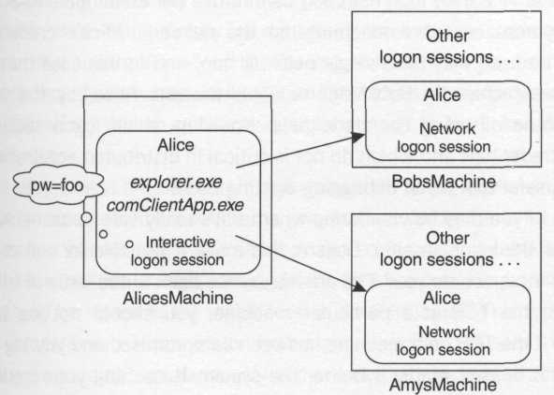
Figure 2.1. Network credentials

The beauty of the logon session is that applications launched on Alice's behalf can still do work for her, even across the network, without Alice needing to be physically present or even paying attention (see Figure 2.1). Alice can therefore be doing many types of work simultaneously, or just resting while her machine does work on her behalf. This model requires some responsibility on Alice's part, of course (she needs to remember to log out or lock her workstation when she goes to lunch), but it is very efficient and reasonable for a commercial operating system.
Having a firm grasp of logon sessions is critical for developers of distributed systems because the logon session dictates many elements of the environment within which a process runs. For instance, in the example mentioned earlier, Alice's interactive logon session on AlicesMachine has cached Alice's credentials in order to be able to satisfy network authentication requests automatically. However, Alice's network logon session on BobsMachine does not normally cache these credentials, and thus processes running on BobsMachine that have access to Alice's logon session cannot use her credentials to access network resources on other machines on the network. Alice's credentials car normally be used only for a single network hop, and in this case that hop was from AlicesMachine to BobsMachine. This protects Alice, by the way, from BobsMachine misusing her credentials. Knowing which logon sessions have network credentials and which do not is critical in distributed application design and is a useful tool when debugging existing code.
Some of you may be wondering whether it's really safe to cache Alice's credentials in the logon session. Doesn't this make it possible for evil code in the system to impersonate you? The answer comes back to the issue of trust. If you don't trust the TCB of a particular machine, you should not log in to that machine. If the TCB on a machine has been compromised and you log in to that machine, it doesn't matter whether the system is caching your credentials or not, because a piece of evil code slipped into the TCB could simply record your keystrokes as you type in your password.

Tokens
Whenever Alice logs in to her workstation and the LSA creates a logon session for her, the LSA also creates something called a token. Each token is always associated with a single logon session, but a given logon session may have many tokens associated with it. Think of the tokens associated with a logon session as simply the surface area of the logon session: They are the things that you can see and touch via the Windows API as a developer. A token is an important level of indirection that allows individual processes to make localized changes to the security attributes for the logon session. Let me illustrate with an example.
Have you ever passed NULL for the lpsecurity_attributes parameter when creating an executive object (for example, a process, thread, section, or semaphore)? Actually, I should probably ask if you've ever passed something other than NULL, because most Windows developers have been trained from birth that NULL is the only appropriate value to pass for those parameters. If you were expecting me to say "shame on you, get your act together", surprise! You've actually been doing exactly the right thing (even though you might sometimes have felt a little guilty about it). Passing NULL allows you to implement a consistent security policy by keeping your default security settings centralized in your application. Where are these defaults stored? In the token associated with your process.
To see why tokens are needed, imagine a system without tokens. In such a system, each process's link back to the principal on whose behalf it was running is simply a handle to a logon session, and so the default security settings for new objects that you create (passing NULL for lpsecurity_attributes) would logically be stored in the logon session data structure. This works fine if only one process ever runs under that logon session. However, if several processes were running simultaneously and one of them decided to adjust these default settings, the other processes would also be affected. Clearly we need a repository for volatile security settings associated with a logon session. The token provides this repository by acting as a localized extension of the logon session; this allows certain changes to be made without affecting other processes.
So when Alice logs in and launches several processes, those processes don't simply get a reference directly back to the logon session; instead, each process has its own copy of a token that links back to the logon session, thus providing each process with a certain amount of autonomy. Figure 2.2 shows an example.
It's also interesting to ask yourself this (somewhat remedial) question: Just what is a process anyway? A process is a collection of resources. It has a virtual address space and a handle table that is a collection of references to executive objects, and it contains one or more threads that bring the process to life, operating on the various resources in the process to get work done. Because Windows is a secure operating system, each resource you obtain clearly must be obtained in the name of a particular principal (so the system can perform access checks and audits as appropriate – the operating system doesn't just let you open random objects willy-nilly, as you are well aware). So ultimately, a process is a collection of resources that are being managed by a particular principal.

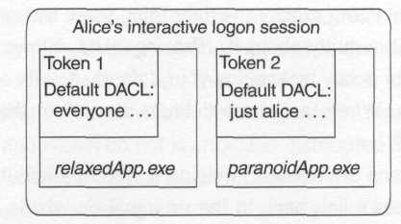
Figure 2.2. Each process has its own token.

With this new perspective on what a process is, it's clear that a process simply cannot exist without an associated principal. And because principal manifest themselves on machines via logon sessions, it's clear that each process absolutely must be associated with a logon session. To give the process some flexibility, each process has a token that links it back to the logon session allowing threads within the process to make slight adjustments to the security settings for the process.
Let's go back to the original example of Alice logging in to AlicesMachine interactively. Once Alice provides her credentials to the logon process, the LSA creates a logon session and a token for Alice. The logon process then launches the shell for Alice, which is typically explorer.exe. The key is that Alice's token is attached to this new process, so that any work the process does (including any resources it obtains programmatically) will be "charged" to Alice. For instance, if the person sitting behind the console selects all the files on Alice's desktop and deletes them, and auditing has been enabled, Alice will be listed in the event log as having performed this action. In this case, explorer.exe performs all its work on Alice's behalf by virtue of the token attached to its process. The token is a piece of out-of-band information that developers don't normally bother thinking about (most folks can get away with this until they start writing distributed applications), but it keeps each process accountable for its actions by associating every action with a principal.
So the shell is happily chugging along under Alice's logon session, and now Alice double-clicks a text file. The shell detects the request and starts a new process by executing some routine that eventually calls CreateProcess to launch Alice's text editor, notepad.exe. This new process must also be associated with Alice's logon session via a token, and therefore CreateProcess simply looks at the calling process's token (that is, Explorer's token) and duplicates it to create a new token for Notepad. Alice now has two processes, and each one is linked back to her single logon session via its own private token.
Imagine now that Alice starts a command prompt (cmd.exe) via the shell, and from that command prompt, Alice runs nmake.exe to build an app she's been working on, and NMAKE spawns a compiler and linker to perform the work. All these processes run within the same logon session and are linked back to it via their own individual tokens. It's so automatic that most developers never even think about it (see Figure 2.3).

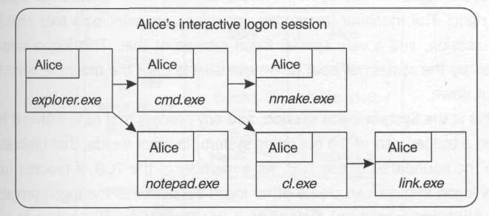
Figure 2.3. Logon session propogation

The System Logon Session
Given this automatic propagation of Alice's token and logon session, it doesn't even seem possible to have multiple logon sessions running simultaneously on the same machine. However, remember the process that was running before Alice even logged in? The logon process itself must run in some other logon session, right? The machine (remember, machines are principals too) also has a logon session, and a very special logon session at that. This logon session is created by the system at boot time, and it lasts until the machine is restarted or shut down.
This is the System logon session, and any process that runs within it is considered a trusted part of the operating system; in other words, that process lives inside the boundaries of the TCB. As a member of the TCB, a process running in this logon session can create other logon sessions (as the logon process did when Alice first logged on) as long as it has the correct credentials to present to the LSA. In fact, an API that will be discussed in more detail in Chapter 4, LogonUser, makes it quite easy to start up new logon sessions on the fly by simply presenting an authority/principal/password tuple.
Many systems developers need the capability to manage logon sessions programmatically, and because LogonUser cannot be called outside the TCB, they will typically want to have their code execute inside the System logon session. How can you get a piece of code to execute inside this special logon session? It's quite simple. Just like in the earlier example in which one process executing within a logon session called CreateProcess to launch an application, running within the same logon session, you can do the same in this case. You just need a process already running in the System logon session to call CreateProcess on your behalf.
This is the job of the System Service Control Manager (SCM). To bootstrap an application into the System logon session, you must write it as a service and install it by calling CreateService (see Chapter 4 for details). The System SCM can then launch your application so that the process runs in the TCB. Not just anyone can install services, for obvious reasons (if a bad guy can install a service on AlicesMachine, he can compromise the TCB of AlicesMachine). Remember who is responsible for defining the boundary of the TCB – the administrator of the machine. Administrators are allowed to install services at their discretion, and they must clearly trust any service they install into the TCB to help enforce the security policy, not to compromise it. It's all about trust! Figure 2.4 shows a typical example of what AlicesMachine might look like when Alice is logged on, including the various types of logon sessions that are discussed in Chapter 4.

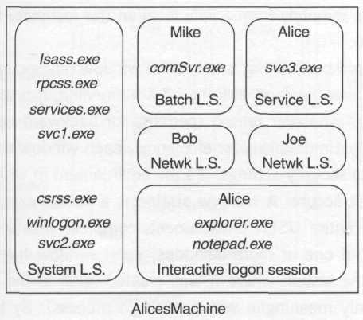
Figure 2.4. A typical collection of logon session

Window Stations
Earlier an example was presented in which Alice uses the shell to select a bunch of files and delete them, and it was noted that even if Alice doesn't happen to be the person sitting behind the console (perhaps she left her desk without locking her console, and a bad guy took her place), it will be Alice's name that shows up in the event log as being charged with deleting those files. Well, wouldn't it be possible for a piece of code executing on Alice's machine to reach in and programmatically do the same thing? For instance, one could imagine a bad guy writing a piece of code that watches for an Explorer window to appear and then sends fake keystrokes (via SendMessage or PostMessage) to the window to simulate Alice deleting files. Alice would watch in horror as her work for the last three months was deleted. In fact, it's possible that the bad guy could initiate this remotely from a safe location (for instance, if it were written as a COM server).
Well, you might be thinking, surely each window has security settings associated with it to keep this sort of thing from happening. It turns out that this is not the case. For whatever reason (perhaps for backward compatibility with older platforms, but more likely for efficiency), each window does not maintain its own individual security settings. It's the environment in which each window lives that keeps it secure. A window station is a secure executive object that encapsulates an entire USER environment, complete with a clipboard, atom table, and a set of one or more desktops. Each window handle is only valid within the window station where it was created (akin to the idea that virtual addresses are only meaningful within a single process). By locking down an entire window station versus individual windows, we simply widen the boundary where security checks need to be performed, thus tremendously improving the performance of the system and simplifying the programming model for user interface developers.
Each process is always associated with a window station, and window stations are assigned at process creation time based on the logon session with which the process is associated (in fact, window station names are normally constructed based on the logon session identifier). To take a concrete example, before Alice logs in to AlicesMachine, there are several processes already running on AlicesMachine under the System logon session (for instance, system services such as the RPC subsystem). There is a window station for the System logon session that naturally hosts these processes. When a COM server is activated (say, from a remote client) on AlicesMachine, the COM Service Control Manager will normally run the server process in a distinct logon session, in which case the server process will run in a window station created specifically for that logon session.
When Alice logs in interactively, her logon session will be assigned to a special window station for the interactive user, named Winsta0, which is different from the other two window stations discussed so far. This window station is known as the interactive window station, and it's special because it's the only window station that can ever receive input from the user sitting behind the console. It's also the only window station whose windows will be displayed on the screen. This prevents the COM server (activated earlier) from being able to send messages to Alice's windows or create its own windows on Alice's window station (perhaps to prompt her for a password illegitimately). Because Alice has her own private window station, with her own private clipboard, she doesn't have to worry about that COM server stealing information from her clipboard or scraping her screen while she's working. Figure 2.5 shows a typical array of window stations.

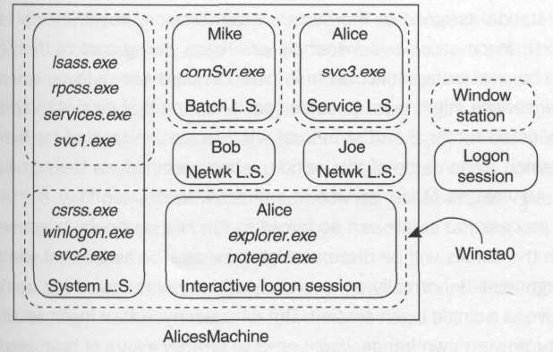
Figure 2.5. A typical collection of window stations

Whereas tokens are used to link processes to logon sessions, window stations are generally used to provide separate USER environments for each logon session. That being said, sometimes it is useful to have a process that is associated with an alternate logon session be able to display windows in Alice's window station or perhaps read Alice's screen. Imagine a screen-reader accessibility application that runs as a service in order to be part of the TCB.
Normally, services that run in the System logon session would run under the window station assigned to the System logon session, not Winsta0. However, the System logon session is extremely privileged (being part of the TCB) and therefore has just as much access to Winsta0 as does Alice's logon session. This particular service might want to use a special option that causes the process to run in Winsta0 rather than the natural window station created for the System logon session. (The name of this option, when specified via the administrative tools for services, is "Allow service to interact with desktop.")
Any process you create can be forced to run in a particular window station. Although the details will be discussed later, for now be aware that window station assignment is normally a no-brainer when you're launching applications that all live in a single logon session. But whenever you take logon session management into your own hands, you'll need to be very aware of how window stations are assigned, lest you assign a process to a window station that doesn't grant access to the process's logon session.
The other gotcha with window station assignment hearkens back to the definition of Winsta0. This is the only window station whose windows can be seen or touched by humans; that is, Winsta0 is the only interactive window station, and all others are considered noninteractive window stations. If you create windows in noninteractive window stations (for instance, the window station associated with the System logon session), you'll get a valid window handle, but no human will ever be able to see your window. So if you call DiaiogBox, for instance, and wait until someone presses a button to call EndDialog, you'll get a nasty surprise because nobody will ever be there to press one of the buttons. In fact, the thread that called DiaiogBox will never return, and DiaiogBox will patiently wait for input that will never come.
The most obvious answer to this problem is "Don't do that". Don't put user interfaces in code running in noninteractive window stations. Don't put user interfaces into components that run in the background as COM servers.
But how many С and C++ programmers use the assert macro to give their debug builds a really nifty user interface that puts up a dialog when an assertion fails that shows exactly which line of code failed and prompts the developer who is testing the build to ask whether the system should wrap a just-in-time (JIT) debugging session around the process? It's clear that debug builds of your applications should always run in Winsta0, unless you either never call assert or you've written your own version that works correctly in a noninteractive window station (see Chapter 5 for an example). Even then, debuggers sometimes have difficulty attaching to processes running in noninteractive window stations in JIT debugging scenarios.
How can you tell whether a given process will run in an interactive or a non-interactive window station? It depends on many factors, but the key is to first become aware of the existence of window stations and understand why they are necessary. Chapter 5 covers the basic rules of window station allocation and shows you when it's appropriate to bend those rules.

Processes
We've already seen two of the most important aspects of a process's security environment: the logon session in which it runs (coupled with the token, which acts as an umbilical cord to that logon session) and the window station in which it runs. However, there are other elements that contribute to a process's environment. Consider, for example, what happens when an application opens a registry key under hkey_current_user. Clearly, the system must map this key onto a physical registry hive, but the mapping depends on the security context of the application. If a process running in Alice's logon session attempts to open this key, the system should clearly use Alice's registry hive to satisfy the request. If a process in Bob's logon session attempts the same thing, the system should use Bob's hive. Printer settings and the user's desktop directory are other settings that are principal sensitive. All this information is stored in a file system directory known as the user profile.
Programs that are designed to run in the interactive logon session will naturally require access to the per-user state that is maintained in the user profile. Daemon processes (specifically COM servers) should not rely on any information in the user profile because profiles weren't designed with this in mind and aren't automatically loaded for COM servers, because loading a profile can be a very expensive operation. Sophisticated applications that broker logon sessions will sometimes need to worry about loading user profiles, however. Chapter 5 discusses these details.

Summary
- A logon session represents the presence of a principal on a machine.
- A single principal may have several logon sessions on a particular machine simultaneously, but each logon session represents only a single principal.
- Each process is associated with a logon session. Always.
- Each process is connected to its logon session via a token.
- A token provides a link back to the logon session, but also allows customization of certain volatile security settings such as default settings for new objects. This allows the system to apply a consistent security policy when new objects are created from within the context of a particular process. Passing NULL for lpsecurity_attributes is usually the right thing to do!
- There is exactly one System logon session on each machine, which is created when the operating system boots and is destroyed when the operating system shuts down. Code that runs in this logon session is part of the TCB.
- The way to bootstrap a process into the System logon session is to write your program as a service. Thereafter, calling CreateProcess will inject other processes into the System logon session.
- Try to run as little code as possible in the System logon session. Assume that any bug in your code will compromise the security of the machine.
- Each window station provides an entire environment for a user interface, complete with clipboard, desktops, and window handles.
- Window handles are window station relative, not machine relative as you may have thought. Avoid using window messages as an inter process communication mechanism.
- User profiles store principal-sensitive environmental information such as environment variables, registry hives, and shell settings.

When tokens are discussed later in this chapter and the next one, you'll see that authorization attributes are technically stored in a token, not in a logon session. However, a token is simply part of the surface area of a logon session; it's the part you can touch as a programmer, as will be discussed shortly.
One of my students showed me the trick of turning off the es_password style bit to discover plaintext passwords in amateurish tools such as DCOMCNFG, which naively reads the existing password and uses it to populate a password edit control. (To be fair, you must be an administrator to run DCOMCNFG.) More sophisticated tools such as User Manager in Windows NT 4.0 populate password controls with spaces, and even better tools (such as the Windows 2000 account editor) don't even display such a control unless you explicitly request to reset or change a password.
Yes, explorer.exe does in fact pop up a dialog if authentication fails, asking for alternate credentials. Is this a good idea? The other alternative would be to allow the user to establish multiple interactive logon sessions, and although this is possible (see Chapter 4), it wouldn't appeal to those users who already have difficulty understanding overlapped windows. Such is the double-edged sword of trying to provide an operating system that is all things to all people.
Under Windows 2000, using a Kerberos feature called delegation, this restriction may be relaxed, but only if certain knobs are turned just the right way in the security database (the details are covered in Chapter 7).
Many system-level developers pass in this data structure to control handle inheritance, but even in this case, most folks pass null for the lpSecurityDescriptor parameter, which I'm also categorizing as "passing null" for the purposes of this book.
Technically, both processes and threads can have tokens; a detailed discussion appears in Chapter 4.
Even the principal for the machine itself has a logon session, which is discussed in detail in Chapter 4.
COM developers should note that the SCM referred to here is not physically the same as the COM Service Control Manager, although their roles are similar. In fact, I chose to call this entity the System SCM specifically to differentiate it from the COM SCM. Microsoft's documentation (as of this writing) doesn't make the distinction between the two.
Technically, a process may dynamically attach to a different window station at runtime, but there are strict access controls on window stations (see Chapter 5) that keep Alice protected
Terminal Services for Windows 2000 (or Terminal Server for Windows NT 4.0) provides somewhat of a twist on this: There can be many client sessions, and each session has its own interactive window station, each of which is named – you guessed it – Winsta0. So the model is the same even when seen through a Terminal Services session. See Kim (1998) for details on how Terminal Services gets away with having multiple executive objects that share the same name.
For those familiar with the way the single-threaded apartment (STA) works in COM, be aware that the window messages used to dispatch messages to an STA are purely there to support thread switching within a single process. COM does not use window messages to perform interprocess communication.

